**ONLINE**

**PERSONAL**

**DIARY**

**Problem statement:**

Design and develop a website for maintaining user’s diary online.

Each user should be able to do each of the following: -

* Make a diary entry in different fonts and to be able to change the theme/background.
* Should be provided with a facility to register an account if they are a new user and the facility to login in case of an old user. The facility to logout as well.
* Should be able to write and delete a diary entry.
* Should be able to see recent public diary entries in feed.
* Should be able to share diary entry link on popular social networking websites (like Facebook, google+ etc…)

**Motivation:**

Whether we’re looking for a tool to track our daily habits, mood fluctuations or daily milestones, a reflective journal is important. My motivation for this project came from my personal experience even when carefully kept, paper journals can be read by anyone who happens to find them. Online diary keeps journals safe with password encryption and we can rest easily knowing our entries are secure in the diary vault.

We can make entries in the online diary from anywhere in the world! as a fellow diary enthusiast this is exciting and convenient.

Writing a daily or monthly record of your life is a good way to make sure your memories are treasured in the purest form through your words and your experiences stay alive. It can also be tremendously therapeutic. It can be helpful to document changes in your life in an online journal. In the midst of hustle and bustle of daily life, there is a dire need for maintaining a diary. We constantly have hundreds of thoughts running through our mind, isn’t it better to write down a few?

**Technologies used:**

This project uses Html, CSS, PHP and MYSQL.

Html stands for Hypertext Markup Language which is used to build webpages on the internet.

CSS stands for cascading style sheets; it is used to style a document.

PHP is a server scripting language, and a powerful tool for making dynamic and interactive Web pages. PHP is a widely used and free.

MySQL is a widely used relational database management system (RDBMS). MySQL is free and open source. MySQL is ideal for both small and large applications.

MAMP is a free, local server environment that can be installed under macOS and Windows with just a few clicks. MAMP provides them with all the tools they need to run **WordPress** on their desktop PC for testing or development purposes, for example. You can even easily test your projects on mobile devices. It does not matter whether you prefer the web server **Apache** or **Nginx** in addition to **MySQL** as database server, or whether you want to work with **PHP**, **Python**, **Perl** or **Ruby**.

**Methodology:**

1. There is a login page in which a user if already registered have to enter his/her username and password if the details are found in the database then the user is redirected to feed page or else there is a link to register themselves.

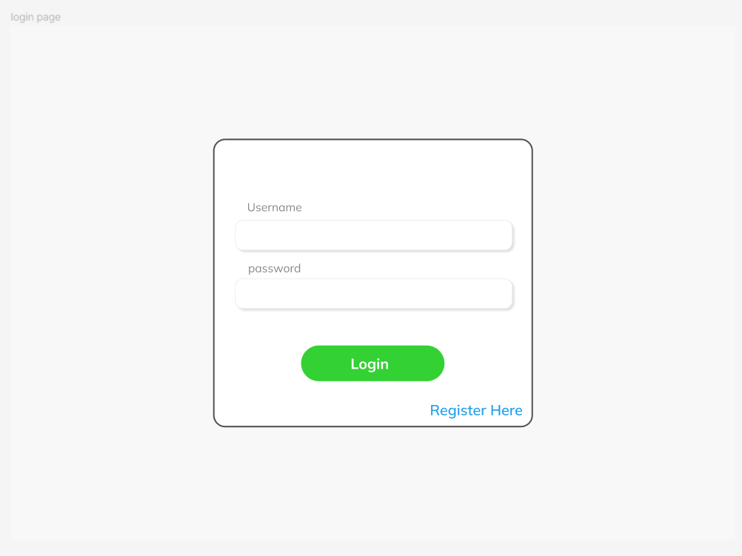

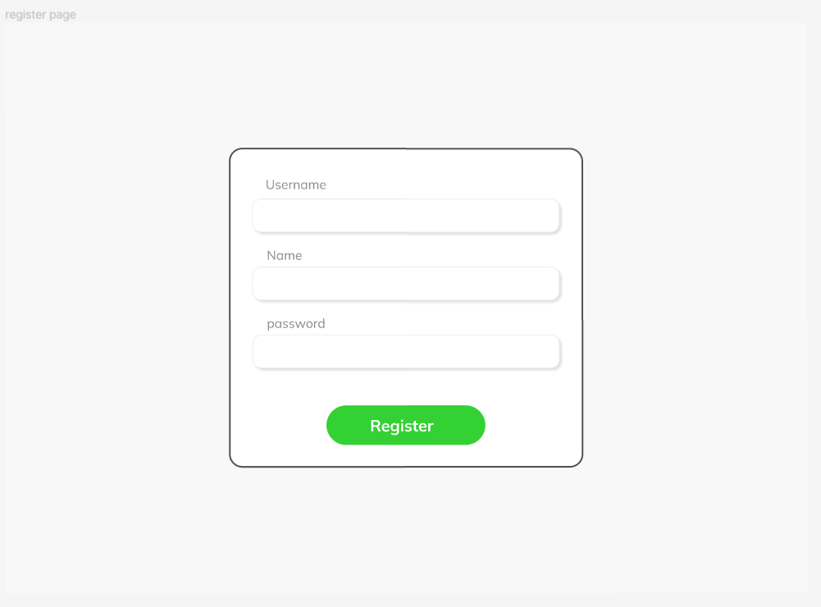

1. The feed page would show the user the recent feed, the feed would have a button which would redirect him/her to the diary entry page in which they could write their entries. The feed page also have a side menu which have a link for the profile page of the user in the profile page the user could see whom he is following and his recent diary entries which he could share. In the feed page if we click on any diary entry we can see that particular diary entry and also interact by commenting.

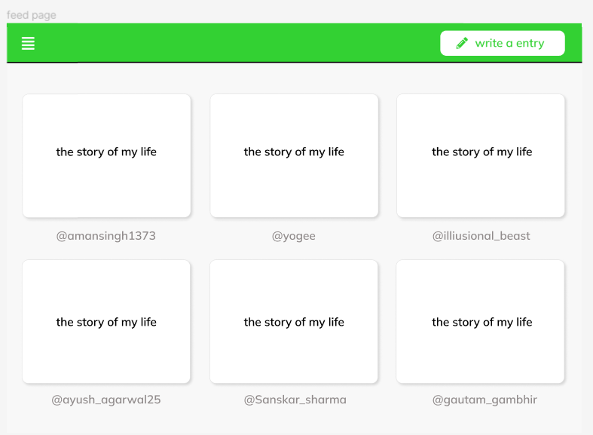

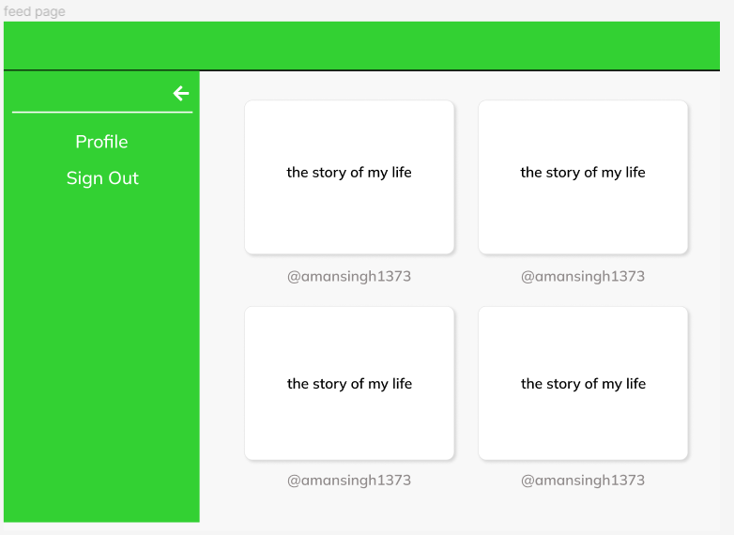

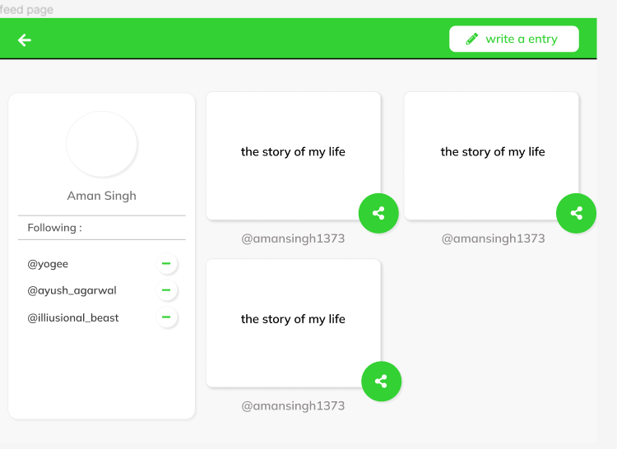

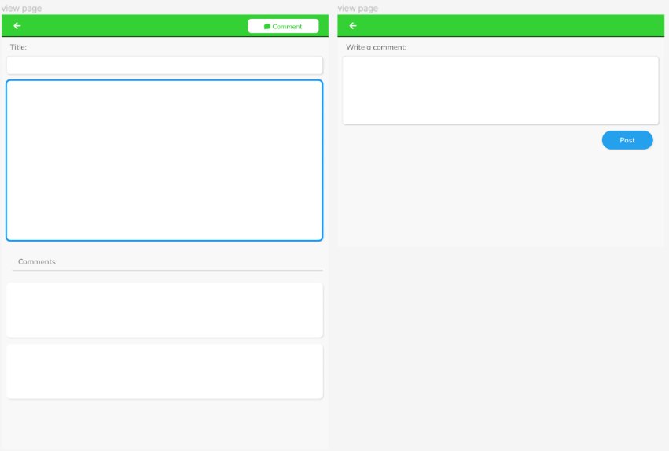

1. The diary entry page consist of ways to edit the data like font size, font-family, color .This entries saved in this page are directly sent to the database.

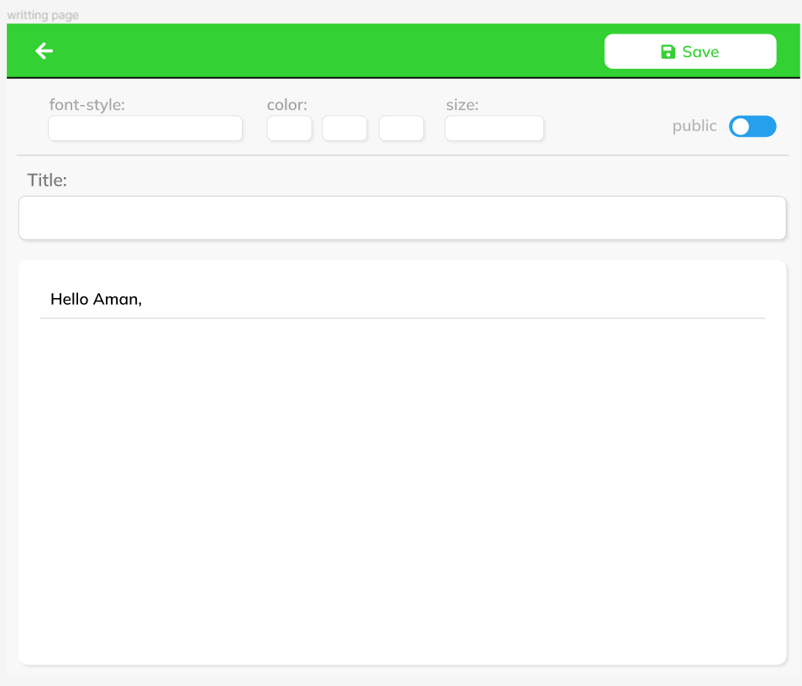

**Database Tables:**

There are three tables inside infobase database namely Users which contains all the detailed of users connected to this web application, Diary_Entry which contains all the details about the entries of the user and then there is Following which contains list of people whom a user is following.

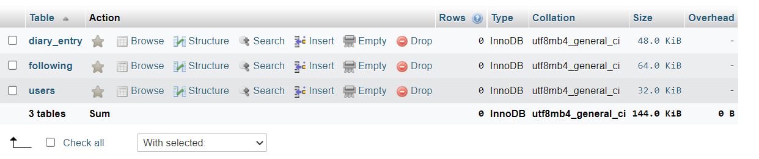

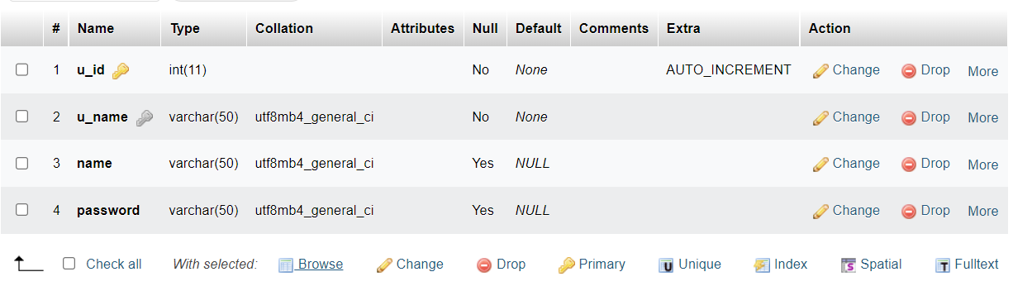

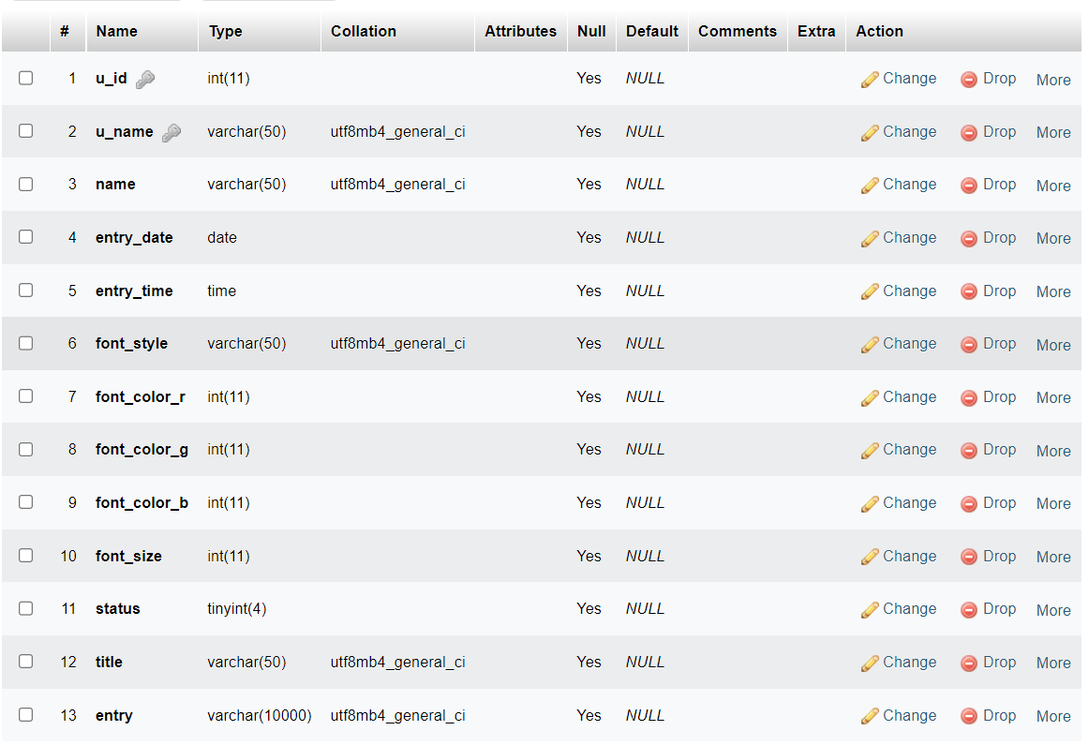

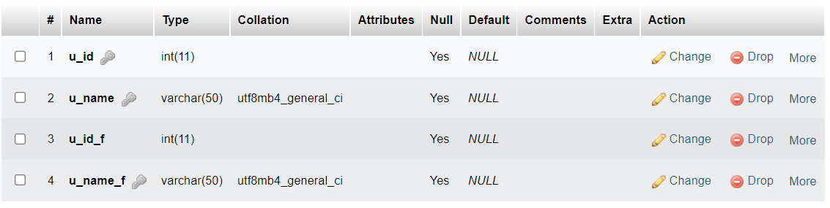

**Conclusion:**

In this project I got a thorough opportunity to dip my hands in front-end and backend technologies. It has made me more interested in exploring how web applications are designed, build and deployed. It’s surely a large process which needs systematic approach followed by a smooth execution.

Links and resources I found useful during this project:

* https://css-tricks.com
* https://W3schools.com
* [https://freefrontend.com](https://freefrontend.com/css-sidebar-menus)
* https://www.codingflicks.com/